**TRƯỜNG THCS PHAN CÔNG HỚN**

**TỔ TIẾNG ANH**

**TIẾNG ANH 7**

**TUẦN 30 (TỪ 07/04 ĐẾN 12/04)**

**Period 88**

**UNIT 9: ENGLISH IN THE WORLD**

**LESSON 2-1 (New words)**

**I. New words**

1. souvenir (n) /suːvəˈnɪr / quà lưu niệm
2. swimsuit (n) /ˈswɪmsuːt/ đồ bơi
3. postcard (n) /ˈpoʊstkɑːrd/ bưu thiếp
4. photo (n) /ˈfoʊtoʊ/ hình ảnh
5. beach (n) /biːtʃ/ bãi biển
6. wallet (n) /ˈwɑːlɪt/ ví

**II. Choose the word or phrase (A, B, C or D) that best fits the space in each sentence.**

1. Our trip to New Zealand was great! We took so many _________________.

A. photos B. wallets C. beaches D. holidays

2. We went to the airport very early because our _____________ departed at 6 a.m.

A. day B. tour C. flight D. sightseeing

3. There are many _________ buildings in Vienna. The oldest one is more than one thousand years old.

A. historic B. modern C. new D. cool

4. My brother forgot his _________________ so I had to pay for him.

A. postcard B. wallet C. photo D. flight

5. I like to buy ______when visiting different cities, but I never write on any of them.

A. postcards B. wallets C. photos D. flights

6. I like to decorate my room with the _________________ I bought from my trips. I have a doll from Japan, a small statue from Cambodia, and some paintings from Malaysia.

A. holidays B. tips C. souvenirs D. presents

7. Our _________________ was great. She was very friendly and helpful. She told us a lot about the history of the town.

A. volunteer B. tour guide C. traveler D. goer

8. We went _________________ and then spent a few days by the sea.

A. making B. doing C. cleaning D. swimming

9. John____ in Singapore at 5 pm yesterday

A. reached B. arrived C. departed D. got

10. At the age of 86, Barry traveled around the world_______ his sidecar.

A. at B. on C. from D. with

**---------------------------------------------------------**🙡🕮🙣**---------------------------------------------------------**

**Period 89**

**UNIT 9: ENGLISH IN THE WORLD**

**LESSON 2-2 (Grammar)**

**I. Grammar : Past Simple : Thì quá khứ đơn**

**1. To be: was/ were**

- we , you, they We were in London last night. (be)

tên người (từ 2 trở lên) 🡪were Lan and Hoa were so happy in the party. (be)

danh từ số nhiều (có s) Were you in Sydney yesterday? (be)

- I, He, she , it He was scared. (be)

Tên người (1 người) 🡪 was I was tired after the trip. (be)

Danh từ số ít

**2. Động từ thường : (V)**

**\*Câu Khẳng định :**

- S + V2/VED Yesterday, I **bought** some souvenirs. (buy – **bought**)

He **watched** a good film last night. ( watch – watched)

**\*Câu phủ định :**

1. They didn’t see him in New York. (not see)

2. She didn’t use suncream though it was hot. (not use)

**\*Câu hỏi:**

1. Did you live in Hue ? Yes, I did. / No, I didn’t.

2. Did she take a lot of photos ? Yes, she did/ No, she didn’t.

SOME **IRREGULAR** VERBS.

* go -went take- took
* lose- lost
* see -saw
* wear- wore
* meet met
* sell- sold
* give- gave
* come- came
* have- had
* eat –ate
* fly- flew

**II. Fill in the blanks with the Past Simple form of the verbs.**

1. We _____________ the Sydney Opera House. (see)
2. I _____________ lots of photos of the castles. (take)
3. We ______________ many delicious Australian dishes. (have)
4. The weather _____________ cold so I wore a big jacket. (be)
5. We ___________ go to the park because it was late when we got back. (not go)
6. My friend just ____________ back from New Zealand. (come)
7. ____________you ____________ lots of tasty food in London? (eat)
8. I ______________ many souvenirs for my friends (buy)
9. We ______________ Sapa last summer vacation. (not visit)
10. Last night we ____________ to Lan’s birthday. (go)
11. We __________________ to this city ten years ago. (move)
12. My mother __________________ me a dictionary last week. (buy)
13. My parents __________________ my grandparents yesterday. (visit)

**III.** **Read the following passage. Decide if the statements from 1 to 4 are True or False and choosethe correct answer (A, B, C or D) for the questions 5 and 6.**

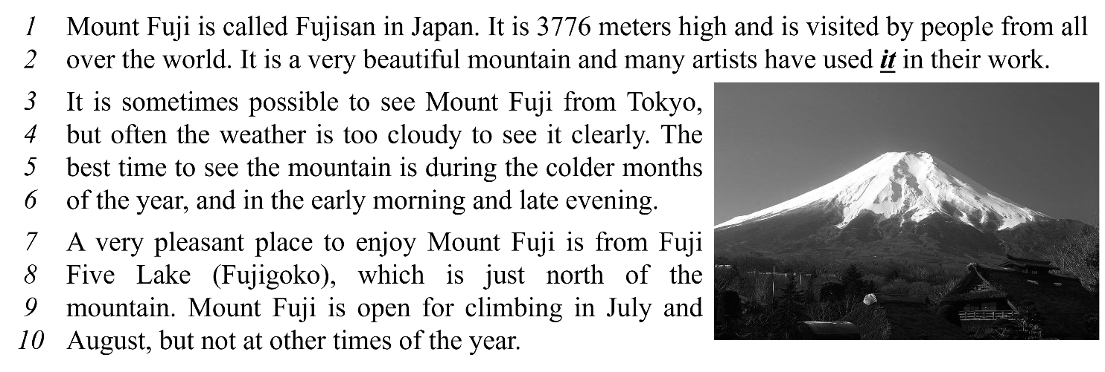 ***Write TRUE or FALSE.***

1. Mount Fuji is a high mountain. ________

2. We can see Mount Fuji clearly every day. ________

3. Fuji Five Lake is in the north of Mount Fuji. ________

4. In December, we can go climbing in Mount Fuji. ________

***Choose correct answer for each question.***

5. What does the word ***it*** in line 2 refer to?

A. the world B. Mount Fuji C. Japan D. artists

6. When is the best time to see Mount Fuji?

A. from Fuji Five Lake B. in August

C. in cold months D. In Summer

**---------------------------------------------------------**🙡🕮🙣**-------------------------------------------------------**

**Period 90**

**UNIT 9: ENGLISH IN THE WORLD**

**LESSON 2-3 (Pronunciation)**

**I. Find the word whose underlined part differs from the other three in pronunciation.**

1. A. America B. summer C. postcard D. department
2. A. souvenir B. parliament C. ferry D. demon
3. A. weather B. wallet C. Australia D. hover
4. A. attraction B. decorate C. tradition D. swimsuit
5. A. holiday B. muddy C. sculpture D. subway

**II. Find the word that differs from the other three in the position of primary stress.**



1. A. cheesesteak B. stadium C. historic D. muddy
2. A. balloon B. participant C. exchange D. roastery
3. A. defeat B. temple C. national D. gallery
4. A. parliament B. comfortable C. negative D. competition
5. A. disappointed B. experience C. transportation D. volunteer

**III. Choose the word (A, B, C or D) that best fits the space in the following passage.**

Dear Ben,

I’m glad to hear about your trip. Last Sunday, students from my school also (11) ______ on an excursion. We visited Củ Chi tunnel. We came to school at 6:00 AM. Ten big buses (12) ______ us there. All of us (13) ______ excited, so we sang all the way to Củ Chi. We arrived there at 7:00 AM. A tourist guide showed us the historical places: the Củ Chi long tunnel and the kitchen under the ground where people cooked their meals. We made a tour around that place.

Then we went to Bến Dược temple we (14) ______ lots of names of the soldiers on the walls. We admired them very much. Our teacher asked us to write a report. We (15) ______ writing it now. We feel very happy to write what we’ve learned from that trip. We hope to come back to Củ Chi someday.

As I’ve mentioned, I have to finish my report, so I’ll stop now. Hope to hear from you soon.

Jerry

1. A. go B. goes C. went D. gone
2. A. took B. taked C. take D. taken
3. A. are B. were C. was D. is
4. A. see B. seed C. sed D. saw
5. A. are B. were C. was D. is

**IV. Rearrange the groups of words in a correct order to make complete sentences.**

1. souvenirs / Yesterday, / bought / I /.//  
   🡪Yesterday, .
2. We / delicious / Japanese dishes/ had / many /.//  
   🡪We .



1. new food/ try / you / Did / any /?//  
   🡪Did ?
2. Jimmy / wallet / forgot / his /.//  
   🡪Jimmy .
3. didn’t visit/ because/ Buckingham Palace/ My mom/ late/ it was /.//  
   🡪My mom .

**---------------------------------------------------------**🙡🕮🙣**-----------------------------------------------------**